SCREEN SHOTS OF HTML CSS GRADED PROJECT

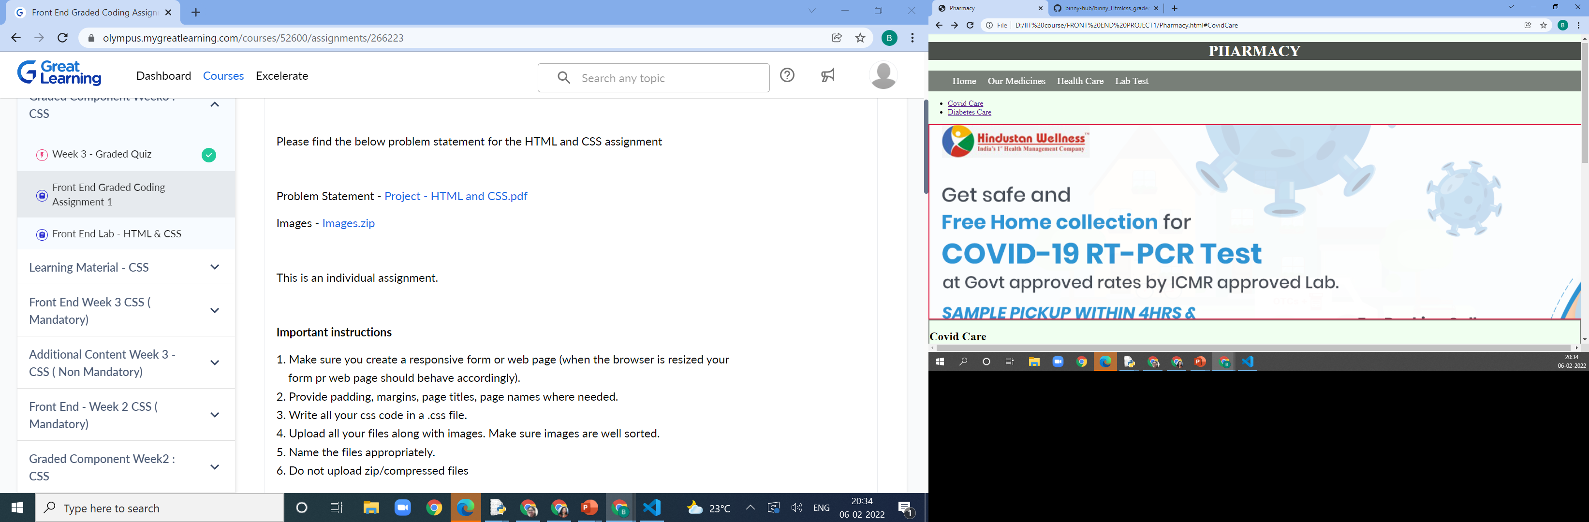

COVID CARE

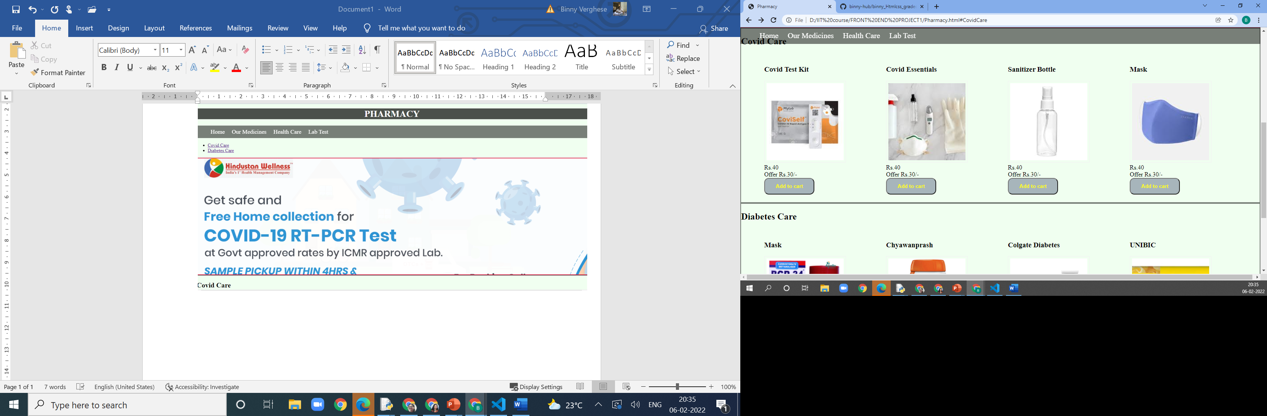

LABTEST

